**What is Static Pod :**

**In Kubernetes, a static pod is a pod that is managed directly by the kubelet on a specific node, without going through the Kubernetes API server. Therefore, you cannot update the configuration of a static Pod using kubectl, and you cannot use features like rolling updates or resource quotas with static Pods.**

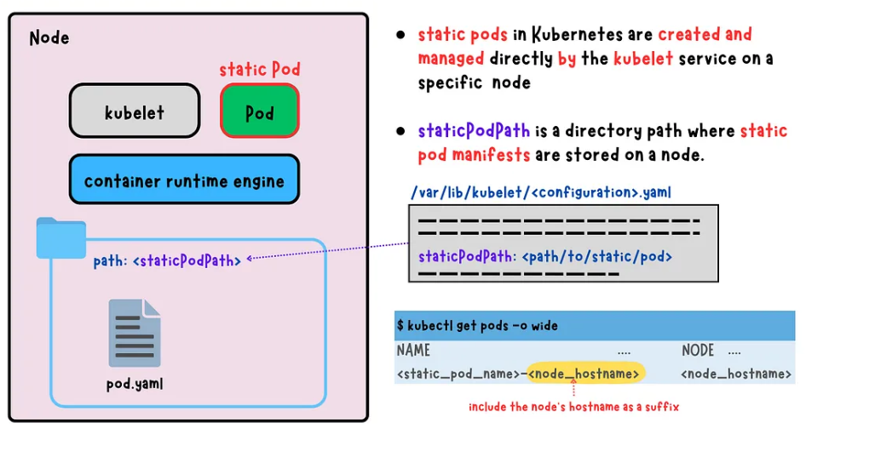

**Kubectl get pods -n kube-system - To check the static Pods**

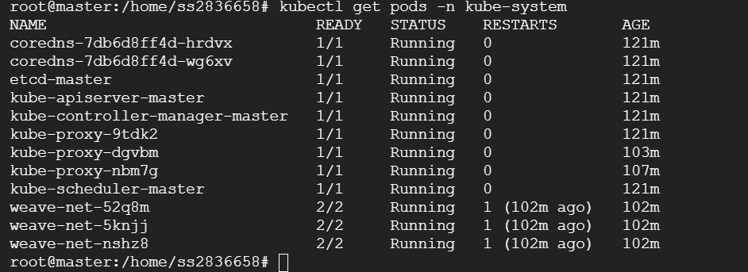

**ls -la /etc/kubernetes/manifests – To See the Manifest Files :**

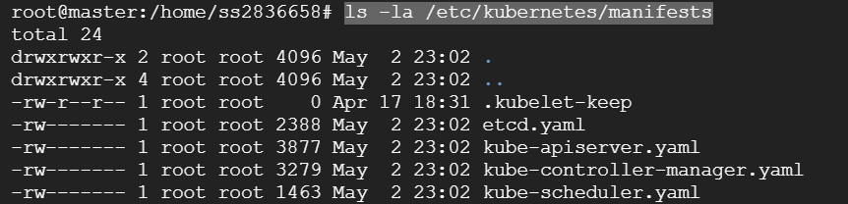

**Downtime Upgrades /Zero Downtime Upgrades:**

**Drain/Cordon : Cordon : Unschedulable – New Node is not going to schedule on this node whichever it is Cordon :**

**Drain means graceful termination all the pods will move to the new node**

**Create a deployment :**

**Kubectl create deployment nginx-deployment –image nginx –replicas=2**

**kubectl run nginx-pod --image nginx**

**kubectl get pods –o wide**

**kubectl get nodes**

**kubectl cordon worker-1**

**create a new deployment :**

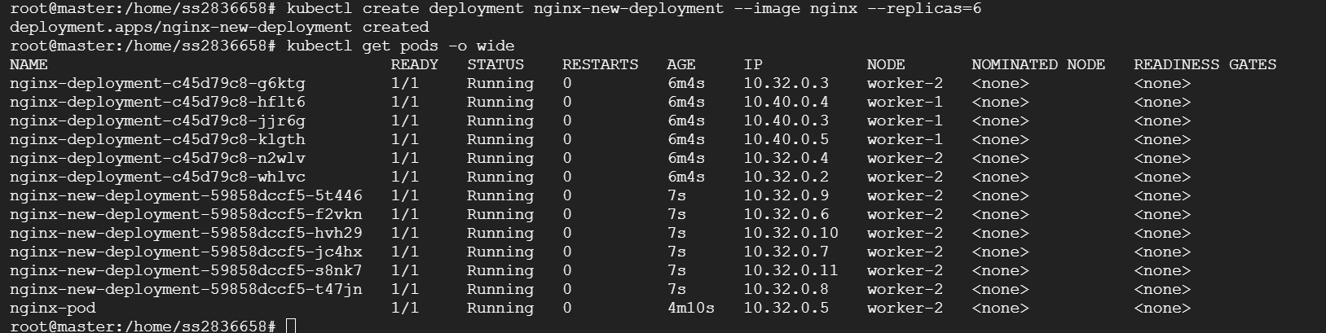

**Now Peform the drain :**

**Kubectl drain worker-1 –ignore-deamonsets –force**

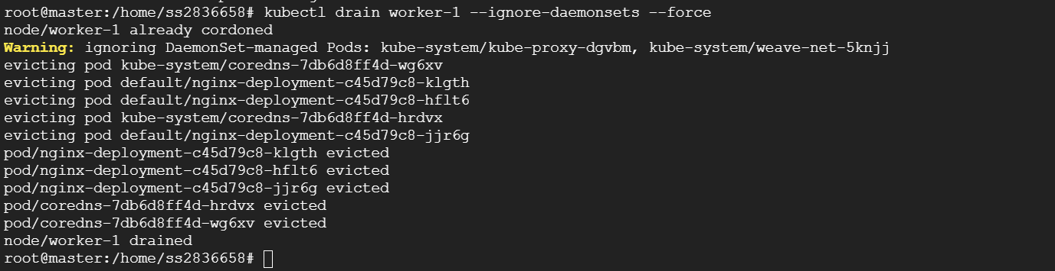

**Kubectl uncordon :**

**kubectl create deploy blue-app --image devopswithcloudhub/nginx:blue --replicas=2**

**kubectl expose deploy blue-app –port 80 –target-port 80 –type LoadBalancer**